**From:** Post 2011 Review [<mailto:eepost2011review@bpa.gov>]   
**Sent:** May 2, 2014

**Subject:** Post-2011 Energy Efficiency Review Update #10 –Reminder Open House and Big Tent May 8

Dear Stakeholders,

Before you head off to Kennewick for the [Efficiency Exchange](http://www.efficiencyexchangenw.com/) conference, we wanted to remind you of the two Post-2011 Review related events on May 8. BPA staff and co-chairs who are at the conference should also be able to answer logistical questions.

**Thursday, May 8**

**7:00 to 8:30 am Open House at the Three Rivers Convention Center**

All BPA cochairs, will be on hand to answer questions about the process and about the recommendations.  BPA chose the convention center for this open house style meeting because many folks will be assembling to get on the buses for the conference tours which start between 7:30 and 8:00 am, or may wish to drop by before they head home after the conference. Unfortunately, BPA cannot provide breakfast.

**2:00 to 5:00 pm Big tent meeting at Benton PUD, 2721 W. 10th Avenue, Kennewick, WA** [**map**](http://www.mapquest.com/maps?city=Kennewick&state=WA&address=2710+W.+10th+Ave.&zipcode=99336)

BPA and utlity co-chairs will make full presentations of their recommendations.

If you have any questions please contact Summer Goodwin, [sggoodwin@bpa.gov](mailto:sggoodwin@bpa.gov), 503-230-3158.

Kathy Moore from Umatilla Electric suggests the following: If you are traveling past Boardman, Oregon on your way to the Tri-cities, you might want to check out the Sustainable Agriculture and Energy (SAGE) Center, an interactive visitor center that highlights sustainable agriculture and energy in the northwest. Interactive displays include food processing, agriculture and how products are delivered around the world. For more information visit their web site: [http://www.visitsage.com/.](http://www.visitsage.com/)

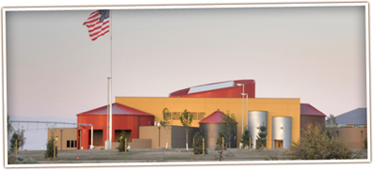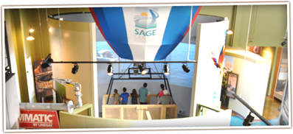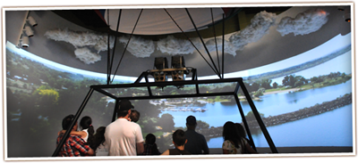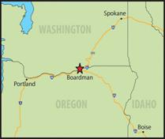

**Directions from I84**

Coming from East or West on I84 take exit 164 and turn towards the river.

Take an immediate right on Front Road and end at 101 Olson Road.

**Driving distance to the SAGE Center**

|  |  |
| --- | --- |
| Portland, OR | 163 Miles |
| Bend, OR | 197 Miles |
| Boise, ID | 268 Miles |
| Tri-Cities, WA | 52 Miles |