Energy Efficiency Post-2011 Review:
Facts and Figures

Introduction

From May to June 2013, BPA performed informal outreach with customers and stakeholders to solicit input on the BPA Energy Efficiency Post-2011 Review (Review). During this outreach, BPA received input on issues of importance as well as on the preferred approach to carrying out the public process. BPA had previously committed to commencing the Review before the fiscal year 2014-2015 (FY14-15) rate period. Customer and stakeholder input, however, showed a strong preference for waiting until BPA had data on fiscal year (FY) 2012-2013 achievements (e.g., savings achievements, cost per aMW, utility self-funding performance) before beginning a formal public process to address outstanding issues of importance. This document provides such data. For more information concerning the Review, visit http://www.bpa.gov/Energy/N/post-2011/index.cfm.

- What is the breakdown of the 504 aMW savings target, on a planning basis?

The table below represents the breakdown of the savings target for the 2010-2014 period. The table is slightly adjusted from the one published in the 2012 Update to the 2010-2014 Action Plan for Energy Efficiency, but has not been updated for achievements to date.

Summary of Energy Savings and Targets (aMW, 2010-2014) - Adjusted
*Totals may not be summed from components due to rounding to nearest whole number. Total reported 6th Plan savings accounts for one-year measure life adjustments to annual reported savings.

The chart below breaks the 504aMW savings target down by savings type, with the first four lines in the table above aggregated together to represent the total percentage of programmatic savings.

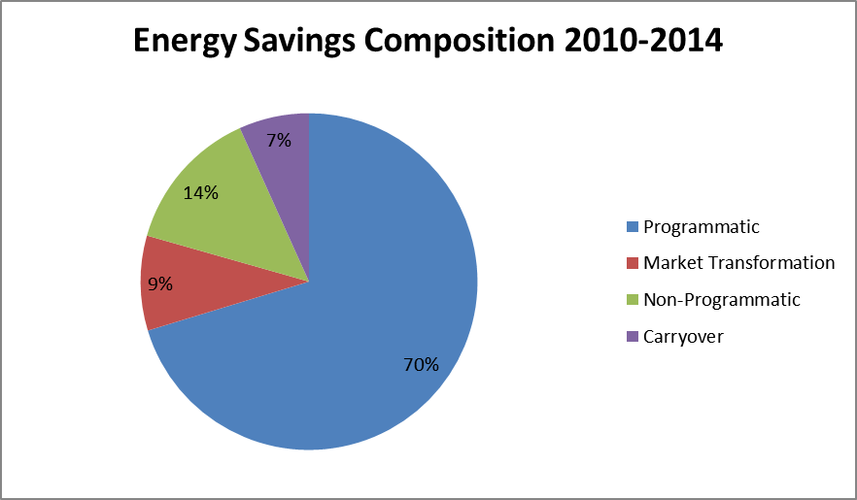

- How was the 504 aMW savings target for BPA determined?

42 percent of the Council’s Sixth Power Plan savings target of 1,200 aMW is BPA’s target of 504 aMW. The 42 percent represents BPA’s share of regional energy sales and was calculated by dividing regional sales (MWh) by BPA sales (MWh), based on EIA form 861 data. Note that the Mid-C public utilities (i.e., Chelan County PUD #1, Douglas County PUD #1, and Grant County PUD #2) are not included in the 42 percent because they do not have a firm power sales contract with BPA.

- What were the programmatic energy savings achievements for FY2012-2013?
UPDATED
 | FY2012 and FY2013 Programmatic Savings Achievements*
 | FY2012 |  |  | FY2013 |  |  | Rate Period
 | Target | Achieved | % of Target | Target | Achieved | % of Target | Target | Achieved | % of Target
Self-funded | 16 | 12.2 | 76% | 14 | 26.1 | 186% | 30 | 38.3 | 128%
BPA-funded | 46 | 47.0 | 102% | 42 | 44.8 | 106% | 88 | 91.8 | 104%
Total | 62 | 59.2 | 95% | 56 | 70.9 | 107% | 118 | 130.1 | 100%
 | *As of March 18, 2014. Includes 6.87 aMW of Norpac savings in FY2012 and BPA's associated payment.
As of the end of the FY12-13 rate period, BPA and its public power customers have achieved 85% of the programmatic target for the Sixth Power Plan while being 80% of the way through the Power Plan.
- What are the BPA Energy Efficiency spending targets for 6th Power Plan?
 | 2010 | 2011 | 2012 | 2013 | 2014 | TOTAL
Targets as of 2010 | $47.0¹ | $80.0² | $104.0³ | $111.0³ | $117.0³ | $459
Targets adjusted as of 2012 | $57.9⁴ | $161.8⁴ | $89.0⁵ | $75.2⁵ | $75.2⁵ | $459
Targets adjusted as of 2013 | $57.9⁴ | $161.8⁴ | $82.3⁶ | $81.9⁷ | $75.2⁵ | $459
Sources:
- $15M in Capital and $32M in Conservation Rate Credit (expense)
- Start of Year Budget
- IPR Budgets from the 10/27/10 IPR Close Out Report
- Actuals
- IPR Budgets from the 10/12 IPR Close Out Report
- Reflects $60.4M in EEI capital spending + the budget for BPA-managed capital of $21.9M
- 2013 Operating Year Budget (reflects “carry over” of 2012 EEI funding)

- How was the Large Project Fund used during FY2012-2013?
Amount of funding disbursed | $1.03 million
Utility requests for funding from the Large Project Fund | 2

One disbursement totaled approximately $908,000 and the other disbursement totaled approximately $122,000.

- How were bilateral transfers used during FY2012-2013?
Number of Transfers | Total Amount Transferred | Largest | Average | Smallest
61 | $5,551,422 | $1,500,000 | $91,006 | $4,188

- How was the Unassigned Account used during FY2012-2013?
Amount of total funding disbursed | $6,227,647
Amount of BPA-managed capital moved to the Unassigned Account | $5,899,996
Amount of customer EEI funding moved to the Unassigned Account | $327,651
Number of customers that received funding from March 2013 allocation | 38
Number of customers that received funding from July 2013 allocation | 34

- How much EEI remained at the end of the rate period?
Updated
Customers with Remaining Budget | Total | Largest | Average | Smallest
67 | $1,053,656 | $143,059 | $26,874 | $2

- How much was paid out in performance payments relative to EEI?
Percent of total EEI BPA planned would be claimed as performance payments | 22%
Percent of total EEI actually claimed as performance payments | 16%

The data provided below is in response to some of the follow-up questions that were raised during the January 16 meeting of Workgroup One. See the accompanying Excel file for additional data related to savings and costs.
- What is the 6th Power Plan breakdown of energy savings (aMW), by sector and funding source?
- How has the average cost changed during the 6th Power Plan for savings funded by BPA?
- How many customers received funding from the Unassigned Account and had remaining EEI at the end of the rate period?
Number of customers that received Unassigned Account funding and had remaining EEI at the end of the rate period | 19

- Can the amounts of remaining EEI at the end of the rate period be put into percentages to provide context?
Highest percentage of EEI remaining relative to rate period EEI budget | 30%
Average percentage of EEI remaining (for those utilities that had remaining EEI) relative to rate period EEI budgets | 1.8%

- What is the FY12 and FY13 Capital breakout of EEI and BPA Managed Capital?

Summary of Capital
 | FY12 | FY13 | Total
BPA Managed | $21,223 | $14,267 | $35,490
EEI | $60,393 | $64,109 | $124,502
Total | $81,616 | $78,376 | $159,992
** Reported in 000

The table here, as opposed to the table in the action plan, breaks out Norpac savings into BPA-funded and Self-funded.
Grant County PUD #2 was excluded from the 42 percent calculation but the utility does receive a small EEI budget to reflect load associated with the City of Grand Coulee.
The costs ($M/aMW) are calculated by dividing total BPA payments by total BPA savings for each sector.

