Industrial Compressed Air System Description
May 2006

Compressed air systems may be noisy, but they are necessary. While they may look intimidating, most modern compressed air system are composed of similar major sub-systems and many sub-components. This document is intended to provide you with the basic information about modern compressed air systems.

Major compressed air sub-systems include the compressor, prime mover, controls, treatment equipment and accessories, and the distribution system. The compressor is the mechanical device that takes in ambient air and increases its pressure. The prime mover powers the compressor (typically the electric motor). Controls serve to regulate the amount of compressed air being produced. The treatment equipment removes contaminants and water from the compressed air, and accessories keep the system operating properly. A distribution system consists of the piping that is analogous to wiring in the electrical world - they transport compressed air to where it is needed.
Compressed air storage can also serve to improve system performance and efficiency. Figure 1.1 shows a representative industrial compressed air system and its components.
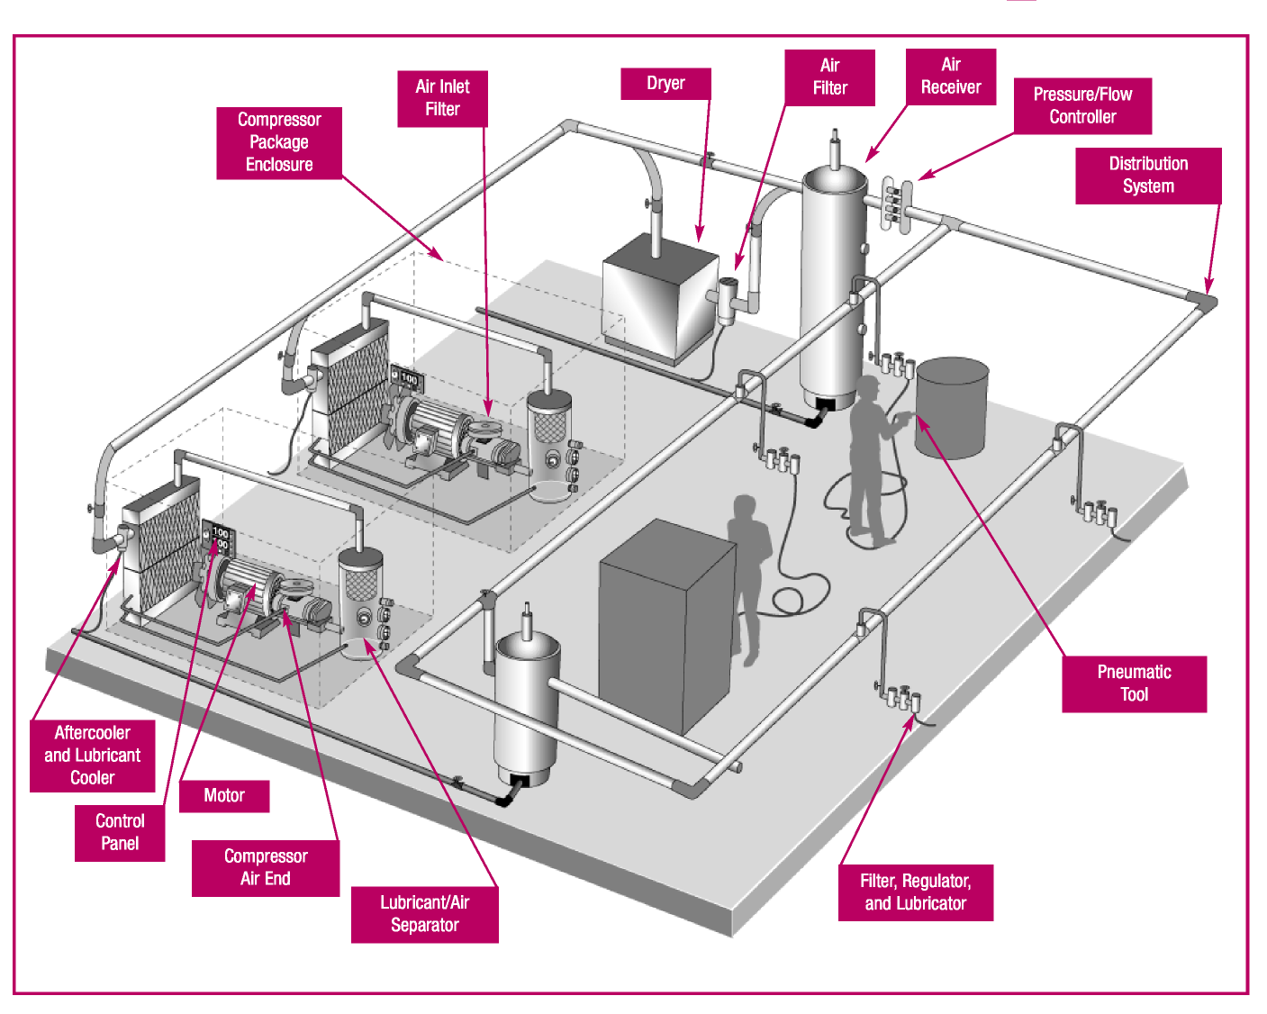
Figure 1.1 Components of a Typical Industrial Compressed Air System

Compressor Types
Many modern industrial air compressors are sold “packaged” with the compressor, drive motor, and many of the accessories mounted on a skid for ease of installation. This skid allows for movement by forklift. Larger packages may require the use of an overhead crane. Some systems also have an enclosure for sound attenuation, cleanliness, and aesthetics.

As shown in Figure 1.2, there are two basic compressor types: positive-displacement and dynamic. In the positive-displacement type, a given quantity of air or gas is trapped in a compression chamber and the volume which it occupies is mechanically reduced, causing a corresponding rise in pressure prior to discharge. At constant speed, the air flow remains essentially constant with variations in discharge pressure. Dynamic compressors impart velocity energy to continuously flowing air or gas by means of impellers rotating at very high speeds. The velocity energy is changed into pressure energy both by the impellers and the discharge volutes or diffusers. In the centrifugal-type dynamic compressors, the shape of air flow and the pressure (or head) generated.
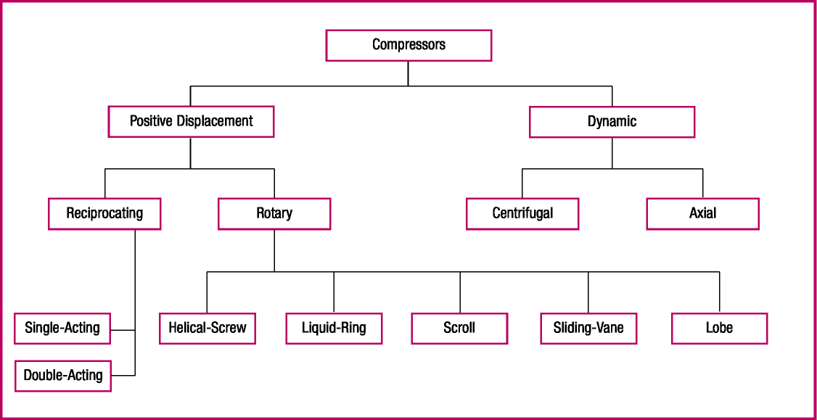
Figure 1.2 Air Compressor Family Tree

Positive-Displacement Compressors
These compressors are available in two types: reciprocating and rotary. Reciprocating compressors work like bicycle pumps. A piston, driven through a crankshaft and connecting rod by an electric motor, reduces the volume in the cylinder occupied by the air or gas, compressing it to a higher pressure. Single acting compressors have a compression stroke in only one direction, while double-acting units provide a compression stroke as the piston moves in each direction. Large, industrial reciprocating air compressors are double-acting and water-cooled. Multi-stage, double acting compressors are the most efficient compressors available, and are typically larger, noisier, and more costly than comparable rotary units. Reciprocating compressors are available in sizes from less than 1 horse power (HP) to more than 600 HP.

Rotary compressors have gained popularity and are now the “workhorse” of American industry. They are most commonly used in sizes from about 30 to 200 HP. The most common type of rotary compressor is the helical-twin, screw-type (also known as rotary screw or helical-lobe). Male and female screw-rotors mesh, trapping air, and reducing the volume of the air along the rotors to the air discharge point. Rotary screw compressors have low initial cost, compact size, low weight, and are easy to maintain. Rotary screw compressors may be air or water-cooled. Less common rotary compressors include sliding-vane, liquid-ring, and scroll-type.

Single-Acting, Reciprocating Air Compressors
This type of compressor is characterized by its “automotive” type piston driven through a connecting rod from the crankshaft. Compression takes place on the top side of the piston on each revolution of the crankshaft. Single-acting, reciprocating air compressors may be air-cooled or liquid-cooled. These may be single stage, usually rated at discharge pressures from 25 to 125 pounds per square inch gauge (psig), or two-stage, usually rated at discharge pressures from 125 psig to 175 psig or higher.

The most common air compressor in the fractional and single-digit HP sizes is the air-cooled, reciprocating air compressor. In larger sizes, single-acting reciprocating compressors are available up to 150 HP, but above 25 HP are much less common. Two-stage and multi-stage designs include inter-stage cooling to reduce discharge air temperatures for improved efficiency and durability.

Pistons used in single-acting compressors are of the “automotive” or “full skirt” design, the underside of the piston being exposed to the crankcase. Lubricated versions have a combination of compression and lubricant-control piston rings, which seal the compression chamber, control the lubricant to the compression chamber, and act (in some designs) as support for piston movement on the cylinder walls.

Lubricant-free, or non-lube designs, do not allow lubricant in the compression chamber and use pistons of self-lubricating materials or use heat resistant, non-metallic guides and piston rings which, are self-lubricating. Some designs incorporate a distance piece or crosshead to isolate the crankcase from the compression chamber.

Lubricant-less designs have piston arrangements similar to lubricant-free versions but do not have lubricant in the crankcase. Generally these have a grease pre-packed crankshaft and connecting rod bearings.

Double-Acting, Reciprocating Air Compressors
Double-acting reciprocating compressors use both sides of the piston for air compression, doubling the capacity for a given cylinder size. A piston rod is attached to the piston at one end and to a crosshead at the other end. The crosshead ensures that the piston travels concentrically within the cylinder. These compressors may be single- or multi-stage, depending on discharge pressure and HP size. These can range upwards from 10 HP and with pressures upwards from 50 psig.

Lubricant-Injected Rotary Screw Compressors
The lubricant-injected rotary screw compressor powered by an electric motor has become a dominant type of industrial compressor for a wide variety of applications.

Compression Principle. The lubricant-injected, rotary screw compressor consists of two intermeshing rotors in a stator housing having an inlet port at one end and a discharge port at the other. The male rotor has lobes formed helically along its length while the female rotor has corresponding helical grooves or flutes. The number of helical lobes and grooves may vary in otherwise similar designs.

Air flowing in through the inlet port fills the spaces between the lobes on each rotor. Rotation then causes the air to be trapped between the lobes and the stator as the inter-lobe spaces pass beyond the inlet port. As the rotation continues, a lobe on one rotor rolls into a groove on the other rotor and the point of intermeshing moves progressively along the axial length of the rotors, reducing the space occupied by the air, resulting in increased pressure. Compression continues until the inter-lobe spaces are exposed to the discharge port when the compressed air is discharged.

Lubricant is injected into the compression chamber during compression and serves three basic functions: 1) it lubricates the intermeshing rotors and associated bearings; 2) it takes away most of the heat caused by compression; and 3) it acts as a seal in the clearances between the meshing rotors and between rotors and stator.

Lubricant-Free Rotary Screw Compressors
The principle of compression in lubricant-free rotary screw compressors is similar to that of the lubricant-injected rotary screw compressors but, without lubricant being introduced into the compression chamber. Two distinct types are available: the dry-type and the water-injected type.

In the dry-type, the intermeshing rotors are not allowed to touch and their relative positions are maintained by means of lubricated timing gears external to the compression chamber. Since there is no injected fluid to remove the heat of compression, most designs use two stages of compression with an intercooler between the stages and an aftercooler after the second stage. The lack of a sealing fluid also requires higher rotation speeds than for the lubricant-injected type. Dry-type, lubricant-free rotary screw compressors have a range from 25 to 4,000 HP or 90 to 20,000 cfm. Single-stage units operate up to 50 psig, while two-stage can achieve up to 150 psig.

In the water-injected type, similar timing gear construction is used, but water is injected into the compression chamber to act as a seal in internal clearances and to remove the heat of compression. This allows pressures in the 100 to 150 psig range to be accomplished with only one stage. The injected water, together with condensed moisture from the atmosphere, is removed from the discharged compressed air by a conventional moisture separation device. Similar to the lubricant-injected type, lubricant-free rotary screw compressors generally are packaged with all necessary accessories.

Dynamic Compressors
These compressors raise the pressure of air or gas by imparting velocity energy and converting it to pressure energy. Dynamic compressors include centrifugal and axial types. The centrifugal-type is the most common and is widely used for industrial compressed air. Each impeller, rotating at high speed, imparts primarily radial flow to the air or gas which then passes through a volute or diffuser to convert the residual velocity energy to pressure energy. Some large manufacturing plants use centrifugal compressors for general plant air, and in some cases, plants use other compressor types to accommodate demand load swings while the centrifugal compressors handle the base load.

Axial compressors consist of a rotor with multiple rows of blades and a matching stator with rows of stationary vanes. The rotating blades impart velocity energy, primarily in an axial plane. The stationary vanes then act as a diffuser to convert the residual velocity energy into pressure energy. This type of compressor is restricted to very high flow capacities and generally possess relatively high compression efficiency. Mixed flow compressors have impellers and rotors which combine the characteristics of both axial and centrifugal compressors.

Centrifugal Air Compressors
A centrifugal air compressor has a continuously flowing air stream which has velocity energy, or kinetic energy, imparted to it by an impeller, or impellers, which rotate at speeds that can exceed 50,000 revolutions per minute (rpm). Approximately one half of the pressure energy is developed in the impeller with the other half achieved by converting the velocity energy to pressure energy as the air speed is reduced in a diffuser and volute. The most common centrifugal air compressor is one with two to four stages for pressures in the 100 to 150 psig range. A water-cooled intercooler and separator between each stage returns the air temperature to approximately ambient temperature and removes condensed moisture before entering the next stage. An aftercooler cools the air from the final stage and a moisture separator removes the moisture prior to air delivery to distribution.

The inherent characteristic of centrifugal air compressors is that as system pressure decreases, the compressor’s flow capacity increases. The steepness of the pressure head/capacity curve is dependent upon the impeller design. The more the impeller blades lean backwards from the true radial position, the steeper the curve.

Most standard centrifugal air compressor packages are designed for an ambient temperature of 95° F and near sea level barometer pressure. The dynamic nature of the centrifugal compressor results in the pressure head generated by each impeller increasing as the air density increases. The compressor mass flow and actual cubic feet per minute (acfm) capacity at a given discharge pressure increases as the ambient temperature decreases. Typically, a capacity control system is provided with the compressor to maintain the desired capacity and to operate within the motor horsepower limits. The control system regulates the air flow by means of an inlet throttle valve or inlet guide vanes. The amount of reduction in the flow rate is limited by a minimum point flow reversal phenomenon known as surge. Control systems either unload the compressor or blow off the excess air to atmosphere to avoid this occurrence, which could result in excessive vibration and potential damage to the compressor. Given adequate storage, some manufacturers will operate the compressor controls in a load/unload mode at lower flow conditions.

Centrifugal air compressors range from around 300 to more than 100,000 cfm but the more common air compressors are from 1,200 to 5,000 cfm and with discharge pressures up to 125 psig. These may have several impellers in line on a single shaft or with separate impellers integrally geared.

Centrifugal air compressors provide lubricant-free air delivery as there is no lubricant in the compression chambers. Lubrication for speed increasing gears and the special high-speed shaft bearings is kept away from the compression chambers by means of shaft seals, which may also have air purge and vent connections.

Centrifugal air compressors are high-speed rotating machines and as such, shaft vibration monitoring is mandated to record operational trends and protect the equipment. Automatic control of the compressors is typical and has been greatly improved by the use of microprocessors, which monitor the pressure/capacity/ temperature characteristics as well as main-drive motor current draw. It is important that the manufacturer’s recommended maintenance procedures be followed and that certain maintenance procedures be carried out by qualified staff. This is particularly true of attempts to remove an impeller from its shaft, since special procedures and tools may be involved.

Compressor Prime Movers
The prime mover is the main power source providing energy to drive the compressor. The prime mover must provide enough power to start the compressor, accelerate it to full speed, and keep the unit operating under various design conditions. This power can be provided by any one of the following sources: electric motors, diesel or natural gas engines, steam turbines and combustion turbines. Electric motors are by far the most common type of prime mover.

Electric motors are a widely available and economical means of providing reliable and efficient power to compressors. Most compressors use standard, polyphase induction motors. In many cases, either a standard or a premium-efficient motor can be specified when purchasing a compressor or replacement motor. The incremental cost of the premium efficient motor is typically recovered in a very short time from the resulting energy savings. When replacing a standard motor with a premium-efficient version, careful attention should be paid to performance parameters, such as full-load speed and torque. A replacement motor with performance as close as possible to the original motor should be used. When replacing a drive motor in a compressor that uses a variable frequency drive as part of the control system, use an inverter-duty motor.

Diesel or natural gas engines are common compressor power sources in the oil and natural gas industries. Considerations such as convenience, cost, and the availability of liquid fuel and natural gas play a role in selecting an engine to power a compressor. Although the majority of industrial compressed air systems use electric motors for prime movers, in recent years there has been renewed interest in using non-electric drives, such as reciprocating engines or turbines powered by natural gas, particularly in regions with high electricity rates. Standby or emergency compressors may also be engine-driven to allow operation in the event of a loss of electrical power. Maintenance costs for engine-driven systems are significantly higher than those that use electric motors.

Compressed Air System Controls
Compressed air system controls serve to match compressor supply with system demand. Proper compressor control is essential to efficient operation and high performance. Because compressor systems are typically sized to meet a system’s maximum demand, a control system is almost always needed to reduce the output of the compressor during times of lower demand. Compressor controls are typically included in the compressor package, and many manufacturers offer more than one type of control technology. Systems with multiple compressors use more sophisticated controls (network or system master controls) to orchestrate compressor operation and air delivery to the system.
Network controls use the on-board compressor controls’ microprocessors linked together to form a chain of communication that makes decisions to stop/start, load/unload, modulate, vary displacement, and vary speed. Usually, one compressor assumes the lead with the others being subordinate to the commands from this compressor.

System master controls coordinate all of the functions necessary to optimize compressed air as a utility. System master controls have many functional capabilities, including the ability to monitor and control all components in the system, as well as trending data, to enhance maintenance functions and minimize costs of operation. Other system controllers, such as pressure/flow controllers, can also improve the performance of some systems.

The type of control system specified for a given system is largely determined by the type of compressor being used and the facility’s demand profile. If a system has a single compressor with a very steady demand, a simple control system may be appropriate. On the other hand, a complex system with multiple compressors, varying demand, and many types of end uses will require a more sophisticated control strategy. In any case, careful consideration should be given to compressor system control selection because it can be the most important single factor affecting system performance and efficiency. For information about efficiency and compressor controls, see the fact sheet titled Compressed Air System Controls in Section 2.

Accessories
Accessories are the various types of equipment used to treat compressed air by removing contaminants such as dirt, lubricant, and water; to keep compressed air systems running smoothly; and to deliver the proper pressure and quantity of air throughout the system. Accessories include compressor aftercoolers, filters, separators, dryers, heat recovery equipment, lubricators, pressure regulators, air receivers, traps, and automatic drains.

Air Inlet Filters. An air inlet filter protects the compressor from atmospheric airborne particles. Further filtration is typically needed to protect equipment downstream of the compressor.

Compressor Cooling. Air or gas compression generates heat. As a result, industrial air compressors that operate continuously generate substantial amounts of heat. Compressor units are cooled with air, water, and/or lubricant. Single-acting reciprocating compressors are typically air-cooled using a fan, which is an integral part of the belt-drive flywheel. Cooling air blows across finned surfaces on the outside of the compressor cylinder’s cooler tubes. Larger, water-cooled, double-acting reciprocating air compressors have built-in cooling water jackets around the cylinders and in the cylinder heads. The temperature of the inlet water and the design and cleanliness of the cooler can affect overall system performance and efficiency. Centrifugal compressors are generally water-cooled.

Lubricant-injected rotary compressors use the injected lubricant to remove most of the heat of compression. In air-cooled compressors, a radiator-type lubricant cooler is used to cool the lubricant before it is re-injected. The cooling fan may be driven from the main motor-drive shaft or by a small auxiliary electric motor. In plants where good quality water is available, shell and tube heat exchangers generally are used.

Intercooling. Most multi-stage compressors use intercoolers, which are heat exchangers that remove the heat of compression between the stages of compression. Intercooling affects the overall efficiency of the machine.

Aftercoolers. As mechanical energy is applied to a gas for compression, the temperature of the gas increases. Aftercoolers are installed after the final stage of compression to reduce the air temperature. As the air temperature is reduced, water vapor in the air is condensed, separated, collected, and drained from the system. Most of the condensate from a compressor with intercooling is removed in the intercooler(s), and the remainder in the aftercooler. Almost all industrial systems, except those that supply process air to heat-indifferent operations require aftercooling. In some systems, aftercoolers are an integral part of the compressor package, while in other systems the aftercooler is a separate piece of equipment. Some systems have both.

Separators. Separators are devices that separate liquids entrained in the air or gas. A separator generally is installed following each intercooler or aftercooler to remove the condensed moisture. This involves changes in direction and velocity and may include impingement baffles. Lubricant-injected rotary compressors have an air/lubricant coalescing separator immediately after the compressor discharge to separate the injected lubricant before it is cooled and recirculated to the compressor. This separation must take place before cooling to prevent condensed moisture from being entrained in the lubricant.

Dryers. When air leaves an aftercooler and moisture separator, it is typically saturated. Any further radiant cooling as it passes through the distribution piping, which may be exposed to colder temperatures, will cause further condensation of moisture with detrimental effects, such as corrosion and contamination of point-of-use processes. This problem can be avoided by the proper use of compressed air dryers.

Atmospheric air contains moisture. The higher the air temperature, the more moisture the air is capable of holding. The term “relative humidity” is commonly used to describe the moisture content although technically, the correct term is “relative vapor pressure,” the air and the water vapor being considered as gases. When the air contains all the moisture possible under the prevailing conditions, it is called “saturated.” Air at 80 percent relative humidity would contain 80 percent of the maximum possible.

When air is cooled, it will reach a temperature at which the amount of moisture present can no longer be contained and some of the moisture will condense and drop out. The temperature at which the moisture condenses is called the dew point. In general, reducing the temperature of saturated compressed air by 20° F will reduce the moisture content by approximately 50 percent.
When air is compressed and occupies a smaller volume, it can no longer contain all of the moisture possible at atmospheric conditions. Again, some of the moisture will drop out as liquid condensate. The result of both of these situations is a difference between the dew point at atmospheric conditions and the dew point at higher pressures. Drying compressed air beyond the required pressure dew point will result in unnecessary energy and costs.

Different types of compressed air dryers have different operating characteristics and degrees of dew point suppression. The most common types of dryers are discussed below.

- The refrigerant dryer is the most commonly used dryer in the industry, having relatively low initial and operating costs. Refrigerant-type air dryers (cycling and non-cycling) are not recommended for operation in sub-freezing ambient temperatures. The moisture in the compressed air can freeze and damage the dryer. Most refrigerated dryers are equipped with a precooler/reheater that reheats the dried compressed air with an air-to-air heat exchanger using the hot incoming air. This lowers the temperature of the incoming air before it passes through the refrigerant/thermal mass-to-air heat exchanger, reducing the heat load on the refrigerant system. Reheating the dried air prevents condensation on the outside of the compressed air piping in warm humid environments. The refrigerated dryer lowers the dew point of the air to the approximate temperature of the air exiting the refrigerant evaporator.
Cycling dryers cool compressed air indirectly through a thermal storage medium (heat sink, thermal mass, chilled media, etc.) while non-cycling dryers directly cool compressed air in a refrigerant to air heat exchanger. Refrigerant-type cycling dryers are controlled with one or two thermostats to shut off the refrigerant compressor when it is not needed, and a thermal storage medium (sometimes referred to as heat sink, chilled media or thermal mass) prevents rapid cycling of the refrigerant compressor(s).
Refrigerant-type, non-cycling dryers cool the air in a refrigerant-to-air heat exchanger. The cooling effect is from the evaporation of a liquid refrigerant causing moisture in the air to condense. The moisture then is removed and drained by a separator and drain. The temperature of the air leaving the refrigerant evaporator is controlled by a hot gas bypass valve.

- Regenerative-desiccant-type dryers use a porous desiccant that adsorbs the moisture by collecting it in its myriad pores, allowing large quantities of water to be retained by a relatively small quantity of desiccant. Desiccant types include silica gel, activated alumina, and molecular sieves. Normally, the desiccant is contained in two separate towers. Compressed air to be dried flows through one tower, while the desiccant in the other is being regenerated. Regeneration is accomplished by reducing the pressure in the tower and passing previously dried purge air through the desiccant bed. Dryers of this type normally have a built-in regeneration cycle, which can be based upon time, dew point, or a combination of the two.
- Deliquescent-type dryers use a drying medium that absorbs, rather than adsorbs, the moisture in the compressed air. This means that the desiccant medium is used up as it changes from solid to liquid and cannot be regenerated.

- Heat-of-compression dryers are regenerative desiccant dryers that use the heat generated during compression to accomplish desiccant regeneration, so they can be considered as heat reactivated. There are two types: the single-vessel and the twin-tower.
The single-vessel, heat-of-compression dryer provides continuous drying with no cycling or switching of towers. The twin-tower, heat-of-compression dryer operation is similar to other twin-tower, heat-activated, regenerative-desiccant dryers. The difference is that the desiccant in the saturated tower is regenerated by means of the heat of compression in all of the hot air leaving the discharge of the air compressor. The heat-of-compression dryers require air from the compressor at a sufficiently high temperature to accomplish regeneration. For this reason, it is used almost exclusively with centrifugal or lubricant-free rotary screw compressors.
- Membrane technology dryers have advanced considerably in recent years. Membranes commonly are used for gas separation, such as in nitrogen production for food storage and other applications. The structure of the membrane allows molecules of certain gases (such as oxygen) to pass through (permeate) a semi-permeable membrane faster than others (such as nitrogen), leaving a concentration of the desired gas (nitrogen) at the outlet of the generator. When used as a dryer in a compressed air system, specially designed membranes allow water vapor (a gas) to pass through the membrane pores faster than the other gases (air) reducing the amount of water vapor in the air stream at the outlet of the membrane dryer, suppressing the dew point

Compressed Air Filters. Depending on the level of air purity required, different levels of filtration and types of filters are used. These include particulate filters to remove solid particles, coalescing filters to remove lubricant and moisture, and adsorbent filters for tastes and odors. A particulate filter is recommended after a desiccant-type dryer to remove desiccant “fines.” A coalescing-type filter is recommended before a desiccant type dryer to prevent fouling of the desiccant bed. Additional filtration may also be needed to meet requirements for specific end uses.

Compressed air filters downstream of the air compressor are generally required for the removal of contaminants, such as particulates, condensate, and lubricant. Filtration only to the level required by each compressed air application will minimize pressure drop and resultant energy consumption. Elements should also be replaced as indicated by pressure differential to minimize pressure drop and energy consumption, and should be checked at least annually.

Heat Recovery. As noted earlier, compressing air generates heat. In fact, industrial-sized air compressors generate a substantial amount of heat that can be recovered and put to useful work. More than 80 percent of the electrical energy going to a compressor becomes available heat. Heat can be recovered and used for producing hot water or hot air.

Lubrication. In lubricant-injected rotary screw compressors, lubricants are designed to cool, seal, and lubricate moving parts for enhanced performance and longer wear. Important considerations for compressor lubricants include proper application and compatibility with downstream equipment, including piping, hoses, and seals. A lubricator may be installed near a point-of-use to lubricate items such as pneumatic tools. The lubricator may be combined with a filter and a pressure regulator to make up what is commonly called a FRL (filter-regulator-lubricator). The lubricant should be that specified by the point-of-use equipment manufacturer.

Pressure/Flow Controllers. Pressure/flow controllers are optional system pressure controls used in conjunction with the individual compressor or system controls described previously. Their primary function is to stabilize system pressure separate from and more precisely than compressor controls. A pressure/flow controller does not directly control a compressor and is generally not included as part of a compressor package. A pressure/flow controller is a device that serves to separate the supply side of a compressor system from the demand side.

Air Receivers. Receivers are used to provide compressed air storage capacity to meet peak demand events and help control system pressure by controlling the rate of pressure change in a system. If the receiver is located before the air dryer, it is called a ‘wet air’ receiver. If it is located after the dryer, it is called a ‘dry air’ receiver. Receivers are especially effective for systems with widely varying compressed air flow requirements. Where peaks are intermittent, a large air receiver may allow a smaller air compressor to be used and can allow the capacity control system to operate more effectively and improve system efficiency. An air receiver after a reciprocating air compressor can provide dampening of pressure pulsations, radiant cooling, and collection of condensate. Demand-side control will optimize the benefit of the air receiver storage volume by stabilizing system header pressure and “flattening” the load peaks. Air receivers also play a crucial role in orchestrating system controls, providing the time needed to start or avoid starting standby air compressors.

Traps and Drains. Traps (sometimes called drains) allow the removal of condensate from the compressed air system. Automatic condensate traps are used to conserve energy by preventing the loss of air through open petcocks and valves. Poorly maintained traps can waste a lot of compressed air.

There are four methods to drain condensate from the receiver.

- Manual. Operators will manually open valves to discharge condensate. However, this is not automatic, and unfortunately, too often, manual valves are left open to drain condensate from moisture separators, intercoolers, refrigerated dryers, and filters, allowing compressed air to continually escape into the atmosphere.

- Level-operated mechanical traps. Float-type traps do not waste air when operating properly, but they often require a great deal of maintenance and are prone to blockage from sediment in the condensate. Inverted bucket traps may require less maintenance but will waste compressed air if the condensate rate is inadequate to maintain the liquid level (or prime) in the trap.

- Electrically operated solenoid valves. The solenoid-operated drain valve has a timing device that can be set to open for a specified time and at preset adjustable intervals. There are two issues with using these valves:
- The period during which the valve is open may not be long enough for adequate drainage of accumulated condensate.
- The valve will operate even if little or no condensate is present, resulting in the loss of valuable compressed air. Level-operated and electrically operated solenoid valves should have strainers installed to reduce contaminants, which block the inlet and discharge ports of these automatic devices. Motorized ball valves are also used with programmable timers. However, while fairly reliable, these valves can be even more wasteful as the duration of the valve opening is dependent on the valve actuator and is not adjustable.

- Zero air-loss traps with reservoirs. There are various types of zero air-loss traps.
- A float or level sensor operates an electric solenoid or ball valve and maintains the condensate level in the reservoir below the high-level point.
- A float activates a pneumatic signal to an air cylinder to open a ball valve through a linkage to expel the condensate in the reservoir to the low-level point.
- Be sure to drain the reservoir often to prevent the accumulation of contaminants, which could foul the mechanisms of these traps.

The potential for freezing must be considered and provision made for heated drains where necessary. The relatively common practice of leaving a manual drain valve cracked open should not be tolerated because it wastes costly compressed air. Contaminated condensate requires removal of lubricant before the condensate is discharged to a sewer system. It is recommended that the local sewage authority be consulted for allowable contamination levels.
Air Distribution Systems. The air distribution system links the various components of the compressed air system to deliver air to the points-of-use with minimal pressure loss. The specific configuration of a distribution system depends on the needs of the individual plant, but frequently consists of an extended network of main lines, branch lines, valves, and air hoses. The length of the network should be kept to a minimum to reduce pressure drop. Air distribution piping should be large enough in diameter to minimize pressure drop. A loop system is generally recommended, with all piping sloped to accessible drop legs and drain points.

When designing an air distribution system layout, it is best to place the air compressor and its related accessories where temperature inside the plant is the lowest (but not below freezing). A projection of future demands and tie-ins to the existing distribution system should also be considered. Air leaks are an important issue with distribution system and are addressed in another fact sheet. It is important to note that the majority of system leakage will be at the point of use and not in the distribution piping.

Good design would have headers with a slight slope to allow drainage of condensate and drop legs from the bottom side of the header should be provided to allow collection and drainage of the condensate. The direction of the slope should be away from the compressor.

Piping from the header to points-of-use should connect to the top or side of the header to avoid being filled with condensate. Drainage-drop legs from the bottom of the header should be installed to collect the condensate.

NOTE: This information was adapted from the “BestPractices for Compressed Air Systems,” 2003



The Compressed Air Challenge (CAC) is a nationwide government/industry collaborative formed in 1997. The goals of the CAC are to raise awareness in industry to the true costs and efficiency improvement opportunities in compressed air systems operations and to bring compressed air best practices to the plant floor level for American manufacturing. Contact us toll free at 866-442-4247
or www.compressedairchallenge.org for more information

