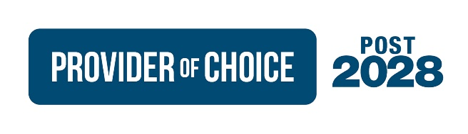

# Fall 2022 Policy Workshop Schedule

# Last Updated: November 16, 2022

# **\*Subject to Change\*** Topics are based on best available information but may change to accommodate other requests or due to changes in availability.

|  |  |  |  |
| --- | --- | --- | --- |
| **Date** | **Time & Forum** | **Workshop Topic** | **Content Type** |
| Wednesday, October 5, 2022 | 9am-12pm; Webex | CHWM Data | Phase 2: Alternative Analysis |
| Fall Workshop Schedule & Overall Timeline | Update |
| Wednesday, October 12, 2022 | 9am-12pm; Webex | IOU Service Overview | Phase 2: Alternative Analysis |
| Rate Construct: Tiered Rates v. Buy and Meld | Phase 2: Alternative Analysis |
| Wednesday, October 19, 2022 | Cancelled | | |
| Wednesday, October 26, 2022 | 9am-12pm; Webex | Resource Acquisition Costs | Phase 2: Alternative Analysis |
| Carbon Overview | Phase 1: Issue Development |
| Billing Credits | Phase 2: Alternative Analysis |
| Regional Dialogue Augmentation | Phase 2: Alternative Analysis |
| Wednesday, November 9, 2022 | 9am-3pm; Webex | Non-federal Resources Overview | Phase 1: Issue Development |
| CHWMs and Resources | Phase 2: Alternative Analysis |
| Thursday, December 1, 2022 | 9am-12pm; Webex | Resource Acquisition Costs | Phase 1: Issue Development |
| Thursday, December 8, 2022 | 9am-4pm; BPA Rates Hearing Room & Webex | Exec Session (Hour 2) | Executive Overview |
| Products | Phase 1: Issue Development |
| Wednesday, December 14, 2022 | 9am-3pm; Webex | NLSL, DSI, IRD/LDD, Transfer | Phase 1: Issue Development |